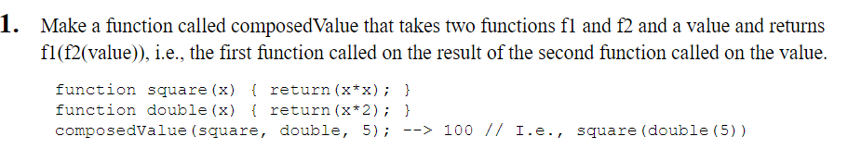

<!DOCTYPE html>

<html>

    <body>

        <script>

            function composedValue(square,double,result){

                document.write("Value is :" +square(double(result)));

            }

            function square(result){

                return(result*result)

            }

            function double(result){

                return(result*2)

            }

            composedValue(square,double,5);

        </script>

    </body>

</html>

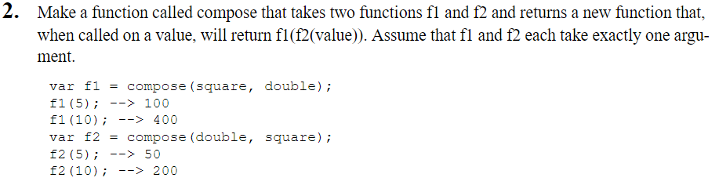

<!DOCTYPE html>

<html>

    <body>

        <script>

            function compose(f1,f2){

                function f3(x){

                    document.write("Value is :" +f1(f2(x)));

                }

                return f3;

            }

            function f1(x){

                return(x*x*4);

            }

            function f2(x){

                return(x*x*2);

            }

            compose(f1,f2) (2);

        </script>

    </body>

</html>

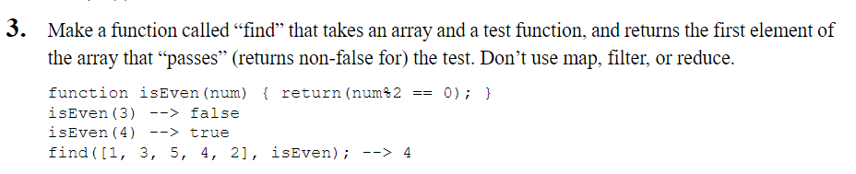

<!DOCTYPE html>

<html>

    <body>

        <script>

            function isEven(n){

                if(n%2==0){

                    return true;

                }

                else{

                    return false;

                }

            }

            var a=[1,3,5,4,2];

            find(a,isEven);

            function find(a,isEven){

                for(i=0;i<a.length;i++){

                    if(isEven(a[i]==true)){

                        document.write(a[i]);

                        break;

                    }

                }

            }

        </script>

    </body>

</html>

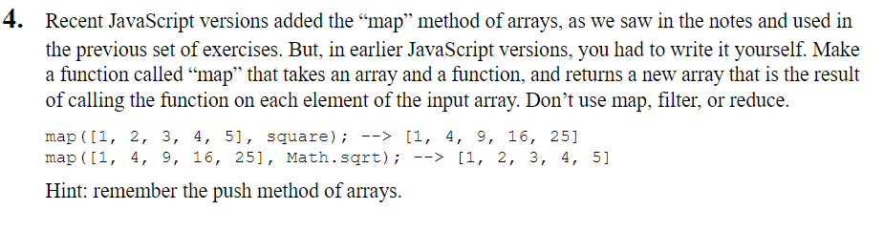

<!DOCTYPE html>

<html>

    <body>

        <script>

            var a=[1,2,3,4,5];

            function map(a,f1)

            {

                var b =[];

                for(i=0;i<a.length;i++)

                b.push(f1(a[i]));

                document.write(b);

            }

        </script>

    </body>

</html>

**FUNCTIONAL PROGRAMMING ADVANCED EXERCISES**

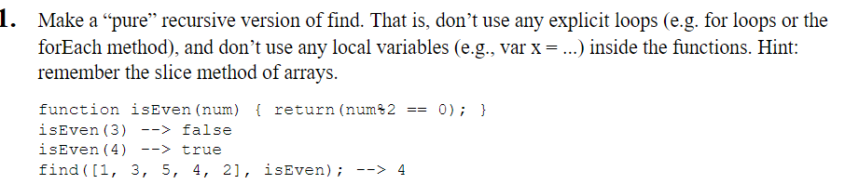

<!DOCTYPE html>

<html>

    <body>

        <script>

            find(a,0,test)

            function find(a,i,isEven){

                if(isEven(a[i])==true){

                    document.write(isEven)

                }

                else{

                    i++;

                    find(1,3,5,4,2)

                }

            }

            function isEven(n){

                if(n%2==0){

                    return true

                }

                else{

                    return false

                }

            }

        </script>

    </body>

</html>

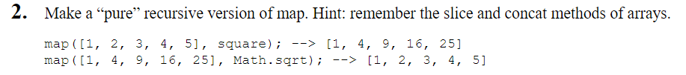

<!DOCTYPE html>

<html>

    <body>

        <script>

            i=0;

            f1 =square;

            console.log(map());

            function map()

        {

        if(i == a.length)

            return;

        else{

           document.write(f1(a[i]));

        i++;

        map();

        }

    }

        </script>

    </body>

</html>